**Morillo Kévin**

**Chennour Adam**

**MMI-TDA**

Site Pataplume: <https://pataplume.fr/>

**Point Positif:**

D’un premier point de vue nous pouvons voir un site très épuré

Un style entre les différentes pages qui respecte la charte graphique

Page Principale du site agréable à la vue

**Point Négatif / Remarque:**

Quand on est dans l’onglet “Chat” nous avons des Info pour des croquettes pour chien.

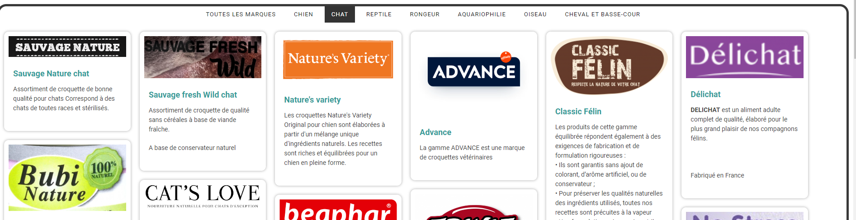

L’onglet “Nos marques” déborde d’informations, on ne sait pas où regarder. De plus, nous n’avons pas assez d’informations pertinentes.

On nous présente des marques différentes avec une légère explication mais pas plus. Nous ne pouvons pas cliquer pour avoir plus d’informations telles que les produits disponibles par cette marque.

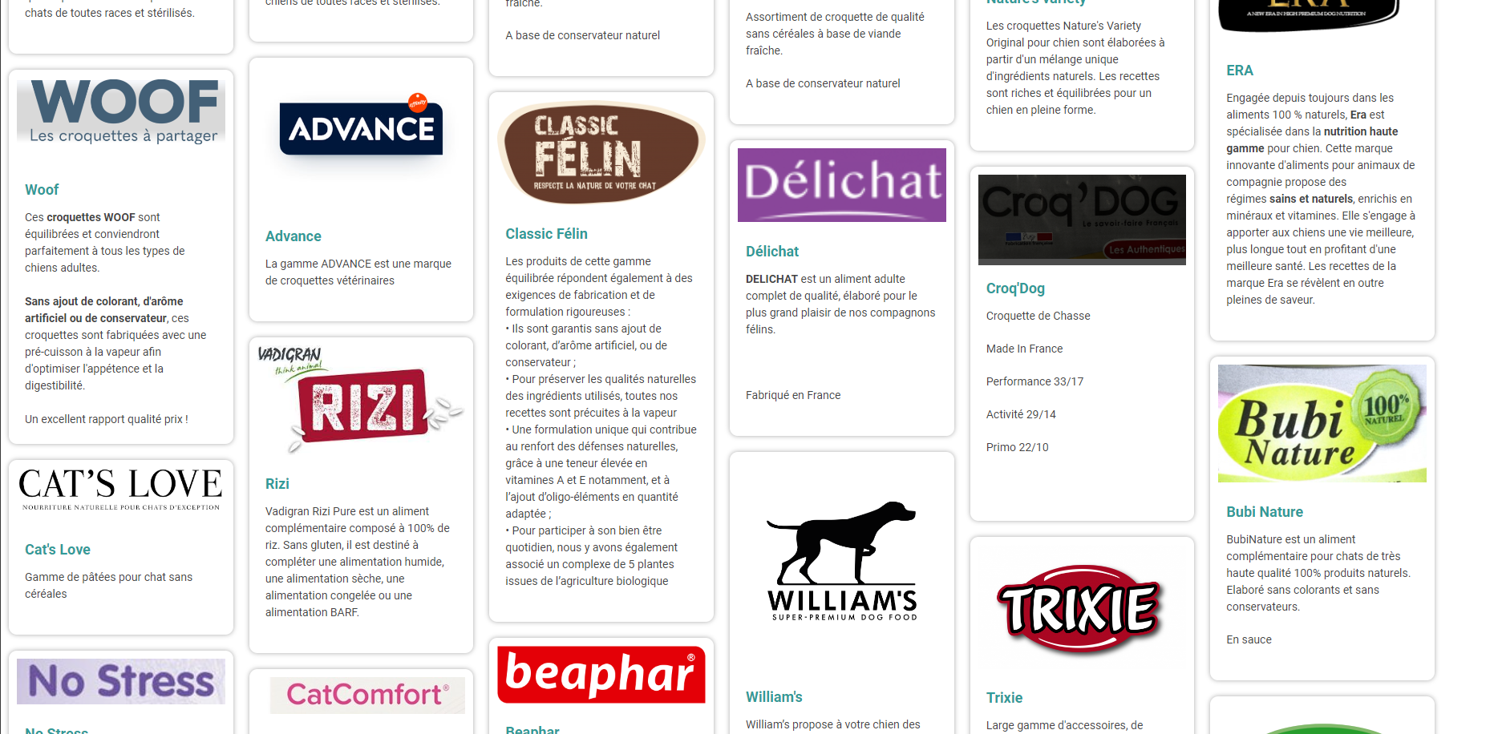

L’onglet “Aquariophilie” une fois de plus nous présente une brève explication de ce qu’on peut retrouver dans ce rayon mais aucuns produits présentés.

De plus, la vidéo nous montre une vidéo de quelques poissons de 20 secondes qui n’est pas très intéressante.

Page d’Accueil : On ne trouve pas directement à l’ouverture du site les informations nécessaires.

On doit y retrouver les coordonnées et les horaires d’ouverture.

L’onglet événement devrait présenter ses offres sur la page principale du site pour que le client soit attiré.

Les informations légales ne sont pas disponibles sur le pied de page.

En bas de la page on retrouve quelques avis qui sont tous positifs, je pense qu’il faudrait mettre par exemple la page d’avis google où une centaine d’avis positif sont disponible.. Là on est retenue à 3 avis déposés.

Dans l’onglet dog wash on retrouve des infos intéressantes mais pas d’informations quant aux disponibilités ou aux prises de rendez-vous.

Le site est dans l’ensemble un peu trop surchargé d'images ou de vidéos interactives que l'on pourrait réduire.

| **Technical and functional aspects** | **Pataplume** | **JMT** | **Emm’Animal** | **Do&Ka** | **Comment** |
| --- | --- | --- | --- | --- | --- |
| The site is sized to fit the screen | Yes | Yes | Yes | Yes | The site layout matches the screen. |
| The site is displayed on all browsers | Yes | Yes | Yes | Yes | The site works on all major search engines. |
| Is the site adapted to mobile devices? | Yes | Yes | Yes | Yes | The site's interface is adapted for mobile phones. |
| The site loads quickly | Yes | Yes | No | Yes | The site loads fairly quickly, unlike the Emm'Animal site, which takes a while to open (4 seconds). |
| The site is not too overcrowded | No | No | Yes | Yes | The "our brands'' tab is overflowing with information, and the user is experiencing cognitive overload. Brands need to be presented more simply and in smaller quantities. That's what the Emm'Animal site is really for, with 7 categories to keep things in order, relevant images and not too much text to avoid being overwhelmed. |
| The site includes a toolbox (a group of site options that perform actions). | No | Yes | Yes | No | The site doesn't offer a toolbox, unlike jmt's, which offers an itinerary button, a contact button and an account creation button, and Emm’animal's, which offers a button for scrolling to the top of the page once you've reached the bottom... |
| The site enables visually impaired users to understand the information on the site. | No | No | Yes | No | The site does not offer any assistance or functionality to help disabled people understand |
| if yes, how ? |  |  | Image description |  |  |

| **Navigation** | **Pataplume** | **JMT** | **Emm’Animal** | **Do&Ka** | **Comment** |
| --- | --- | --- | --- | --- | --- |
| Navigation type | Star | Hierarchical | Hierarchical | Linear | The site's star-shaped navigation is well suited to the site. |
| The menu is immediately recognizable on the site | Yes | Yes | Yes | Yes | The menu is directly visible on the site's opening page. |
| If yes, what type of menu | Horizontal | HorizontalUnwinding | HorizontalUnwinding | Horizontal | We have a horizontal menu that is directly visible when the site is opened. Unlike us, JMT and Emm'Animal have a pull-down menu to show their products. |
| The menu is always visible on the screen | No | No | Yes | No | The menu disappears as soon as you scroll down, unlike Emm'Animal, which leaves the menu at the top of the page for easy navigation, even at the bottom. |
| The site's sections are easily identifiable and self-explanatory | No | Yes | Yes | Yes | I prefer to put no because the names of the categories are not the best, we will prefer adjectives rather than "our aquarium department". |
| The number of main menu items is well chosen | Yes | No | Yes | Yes | The choice of categories is well chosen, unlike JMT, which has 9 categories in the drop-down menu, which is too many. A maximum of 7 categories is possible. |
| Information found in less than 3 clicks | Yes | Yes | Yes | Yes | The information is found in no more than 3 clicks. |
| Link between pages | Useful - Utility | Strucural | Strucural | Useful - Utility | Links between pages are "utilitarian", i.e. you move from one page to another using a button, unlike with JMT or Emm'Animal, which use a hierarchy. |
| If Structural |  | Inverted-L | Horizontal |  | JMT uses a drop-down menu on the vertical left, while Emm'Animal puts a drop-down menu below its main menu. It all depends on how you want to organize things. |
| The site has no incorrect links | No | No | No | No | No erroneous links were found. |
| The site has an efficient search engine | No | Yes | Yes | No | Since we don't offer any products, a search bar is of no use. JMT and Emm'Animal use an efficient search bar that helps us find the product we want quickly. |

| **Graphic Design** | **Pataplume** | **JMT** | **Emm’Animal** | **Do&KA** | **Comment** |
| --- | --- | --- | --- | --- | --- |
| The site is pleasing to the eye | Yes | Yes | Yes | Yes | Each website has its own graphic style, which is quite pleasing to the eye. |
| The site includes a footer | Yes | Yes | Yes | Yes | Each site has a footer. |
| The site is consistent from page to page | Yes | Yes | Yes | Yes | Each site respects its own graphic style from page to page. |
| Limited number of colors | Yes | Yes | No | Yes | Our site respects the maximum number of colors, unlike Emm'Animal, which uses more than 5. Do&Ka also uses a lot of colors, but it's for small logos and brings a more childlike and friendly side that fits well with the site's theme? |
| Visuals (Images, Logo, Icons) provide information | No | Yes | Yes | Yes | The use of logos, images and videos is in some cases a little misused, like the video in the tab "our aquarium department" which shows a not very interesting video of a fish where we would have liked to see images or videos of products available in this department. |
| The brand is clearly identifiable on the site | Yes | Yes | Yes | Yes | On each site, the brand is easily identifiable. |
| The site features a visible, easy-to-remember logo | Yes | Yes | No | Yes | Our logo is really interesting and easily memorable, unlike Emm Animal's which is a little too small and complex. |
| The site doesn't use too many fonts | Yes | Yes | Yes | Yes | The use of fonts is well balanced across all sites. |
| Text is easily visible (size, underlining, italics, etc.) | Yes | Yes | Yes | Yes | The text is quite legible on all the sites. Just be careful with Do&Ka, which has a bit too much text. |
| Lines of force (shapes, zones, shadows) | SquareRectangle | SquareRectangle | SquareRectanglecircle | SquareRectangle | The use of square and rectangle shapes is really nice, they bring security and professionalism. |

| **Information is content** | **Pataplume** | **JMT** | **Emm’Animal** | **Do&Ka** | **Comment** |
| --- | --- | --- | --- | --- | --- |
| A block of circulating information is present | No | No | Yes | No | Only Emm'Animal uses a scrolling block of images, which can be interesting when used well, as it attracts the visitor's eye. |
| Do we have time to read them properly? |  |  | Yes |  | The scrolling is slow enough to visualize the product and not too slow to see the others. |
| Important content  to the fore | No | Yes | Yes | Yes | Particularly in the "our brands" tab, there are so many images and text that you don't get the gist. |

| **Interactivity** | **Pataplume** | **JMK** | **Emm’Animal** | **D&Ka** | **Comment** |
| --- | --- | --- | --- | --- | --- |
| Is there a contact tab on the site? | Yes | Yes | Yes | Yes | Being able to contact the store is essential. All sites have a contact form. |
| It meets legal requirements / The legal notices are present | Yes | Yes | Yes | Yes | Every website needs its own legal notice. |
| The site has a newsletter | No | Yes | No | No | JMK alone offers a newsletter. This is used to inform readers about new products, highlight employees, share success stories and announce upcoming events or promotions. |

| **Specific to e-commerce** | **Pataplume** | **JMK** | **Emm’Animal** | **Do&Ka** | **Comment** |
| --- | --- | --- | --- | --- | --- |
| The site has a secure area for all banking transactions |  | Yes | Yes |  |  |
| The site offers several payment methods |  | Yes | Yes |  |  |
| The site offers a clear and complete invoice following a transaction |  | Yes | Yes |  |  |
| The products are well described | No | Yes | Yes | No |  |